002 Gulp - setting up gulp & first task

Gulp Kata List – Blog Page

[TypeScript Kata List on GitHub](https://github.com/robertdunaway/katas-typescript)

# Duration

10 minutes

# Brief

In this kata we are going to set up a Gulp skeleton and create a test task.

### For More Information

BING/GOOGLE: “Gulp Getting Started”

Book: <http://www.amazon.com/Gulp-Quick-guide-getting-running/dp/151468960X>

# Instructions

Get tutorial folder or the entire katas-angular2 repo.

Open the [before/*.sln] file and execute the kata.

Feel free to execute this kata multiple times because repetition creates motor memory.

# Github

* Before (start kata with this)
  + https://github.com/robertdunaway/katas-gulp/tree/master/002%20Gulp%20-%20setting%20up%20gulp%20%26%20first%20task/before
* After
  + https://github.com/robertdunaway/katas-gulp/tree/master/002%20Gulp%20-%20setting%20up%20gulp%20%26%20first%20task/after

# Kata

In the “before” solution, create the files and programs necessary to use Gulp.

# Review

These katas are demonstrated using Visual Studio 2015 which installs NodeJS so it is assumed Node is installed. If Node is not installed, visit <https://nodejs.org/en/> and install it. NPM is Node’s package manager and we will be using it extensively.

First, navigate to the root director of your project, at the command line, and install Gulp both globally and locally.

npm install gulp -g

Notice the “-g” means global.

Now install Gulp locally. IE: without the “-g”

npm install gulp --save-dev

Notice the “--save-dev”. This tells npm to save the installed program to the package.json file. The package.json file holds metadata about your application.

If your screen looks like this, you are in good shape.

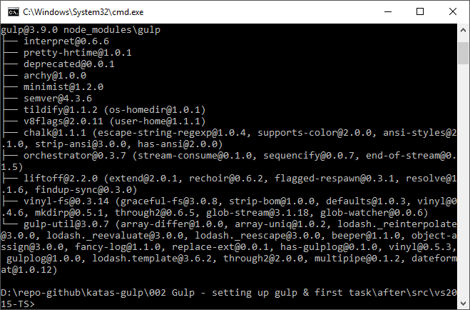

At this point the “--save-dev” command has caused the package.json to be created. This can also be accomplished by executing the command npm init.

If you don’t see the new file, select “Show All Files” in the Solution Explorer. You’ll see both the package.json file and node_modules folder.

Opening the package.json file, at this point, you will see.

{

"version": "1.0.0",

"name": "ASP.NET",

"private": true,

"devDependencies": {

"gulp": "^3.9.0"

}

}

Now is a good time to create our test task.

Create a file named “gulpfile.js”. This will hold all our Gulp tasks.

# Next

Take a few minutes and imagine more examples.